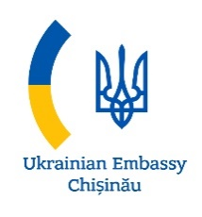 | 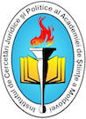 | 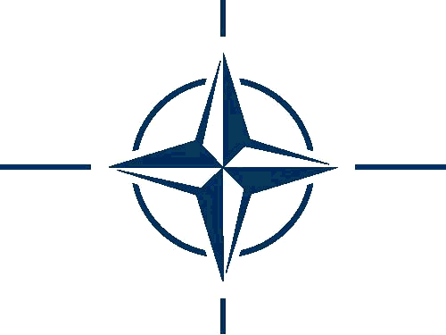
EMBASSY OF UKRAINE TO THE REPUBLIC OF MOLDOVA | LEGAL AND POLITICAL RESEARCH INSTITUTE | INFORMATION AND DOCUMENTATION CENTER ON NATO IN MOLDOVA
Ukraine and the Republic of Moldova:
From Challenges towards Opportunities
Scientific conference with international participation
Thursday, 24th of May 2017
Academy of Sciences of Moldova, Azurie Hall, 1st floor, 1 Stefan cel Mare și Sfint av.
AGENDA
09.00 - 09.30 | Registration of participants
09.30 - 09.45 | Opening remarks:  Valeriu CUȘNIR, doctor habilitat, Director of the Institute of Legal and Political Research (ILPR)  Igor ȘAROV, State Secretary General, Ministry of Education, Culture and Research of the Republic of Moldova  Ion GUCEAC, Academician, Vice-President of the Academy of Science of Moldova
09.45 - 10.35 | SESSION I. REGIONAL SECURITY ENVIRONMENT: CHALLENGES AND OPPORTUNITIES
Moderator: | Victor JUC, doctor habilitat, Deputy Director of the ILPR
Reports: | Ivan HNATYSHYN, Extraordinary and Plenipotentiary Ambassador of Ukraine to Republic of Moldova, Ukraine is the Country of Opportunities.  Gheorghe BALAN, State adviser on country reintegration, Cabinet of the Prime Minister, Settlement of the Transnistrian conflict: developments in the field of security.  Igor MUNTEANU, Executive Director, Institute for Development and Social Initiatives, IDIS ”Viitorul”.
10.35 - 11.05 | Questions, debates
11.05 – 11.30 | Coffee break, Aurie Hall
11.30 – 12.30 | SESSION II. REGIONAL COOPERATION AND OPPORTUNITIES FOR STRENGTHENING OF THE NATIONAL SECURITY
Moderator: | Natalia ALBU, PhD, Centre for Strategic Research, ILPR
Reports: | Serghei GERASYMCHUK, Foreign Policy Council "Ukrainian Prism" (Kiev), Strategic and Security Studies Group, Ukraine - Moldova relations after election: a window of opportunities or a gateway to a deadlock.  Victoria BUCĂTARU, Executive Director of the Association of Foreign Policy (APE), The relationship between the Republic of Moldova and Ukraine in the new regional security environment: cooperation strategies in the Euro-Atlantic area.  Anton MIKHNENKO, Ukrainian Defence Review, Experience in reforming Ukraine's defence and security sectors under the Hybrid war.
12:30 – 13:15 | Questions, debates, interventions

